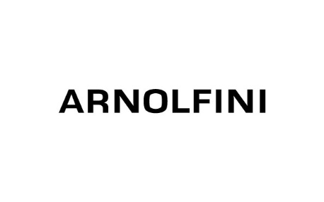

Evaluator Application
DASH and the 3 partners in the Curatorial Commission programme Arnolfini, MIMA and the MAC Birmingham seek to contract an evaluator for the programme.
Evaluator Specification:
- Knowledge and experience of arts evaluation design and delivery
- Experience in handling both quantitative and qualitative research
- Excellent verbal and written communication skills with a range of artists and stakeholders
- Commitment to ensuring that issues of diversity are identified and addressed in the evaluation process
- Excellent organisational skills and the ability to manage multiple priorities
Evaluation requirements
We require:
- Interim report in April 2020 covering:
- Available quantitative data
- Available qualitative data
- Relating the impact of the programme on goals 1/2/5 of the Arts Council
- Final report at the end of the programme (February 2021)
We expect the Evaluator to attend the twice yearly network meets as well as having a presence in each of the partners’ venues.
The role is freelance, with a fixed term contract starting in March/April 2019 and finishing by approximately July 2021. The evaluator is responsible for their own tax and national insurance contributions.
The budget for the evaluation is £9000 inclusive of VAT, travel etc.
To apply please download the evaluator brief http://www.dasharts.org/projects/call-for-evaluator-dash-curatorial-commissions.html
We need the following information as part of your application:
- A current CV
- A covering letter outlining your suitability for the role with reference to the evaluator specification, evaluation brief and the evaluation methodology you will use (1000 words max)
- Your evaluation timeframe

Deadline for applications:
Midnight Friday 22nd February 2019
Please send your applications to paula@dasharts.org

Interviews will be held on
Wednesday 6th March 2019 at the MAC Birmingham

