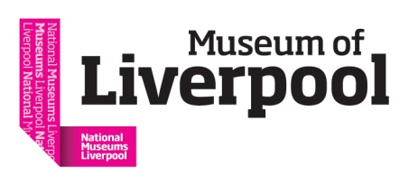
Rethinking Disability: What needs to change in Museums and Galleries?

#RethinkDisability @H_O_P

Symposium speaker biographies

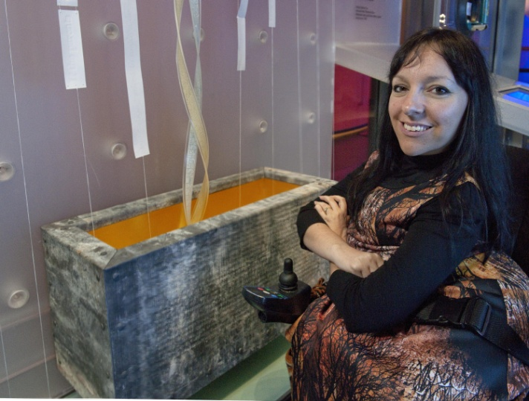

Esther Fox
Esther Fox has worked in the cultural sector for the last 15 years and is passionate about promoting ambitious disabled led cultural activities. In 2009 Esther was appointed by Screen South to lead the 2012 Legacy programme, Accentuate; www.accentuateuk.org.
Accentuate is one of Screen South’s portfolio of projects, creating opportunities for deaf and disabled people to participate and lead in the cultural sector. Leading up to the 2012 Games, Accentuate ensured there was more disabled led cultural activity in the South East than in any other region outside of London. Since then Esther has taken Accentuate forward to have a national remit and has devised a range of new projects, including History of Place. Funded by Heritage Lottery Fund, History of Place charts the lives of deaf and disabled people over 800 years in relation to 8 built heritage sites across the country. Esther is also the Project Manager and Co Investigator on a major Arts and Humanities Research Council project Disability and Community: Dis/engagement, Dis/enfranchisement, Dis/parity and Dissent (the D4D project). Alongside leading the Accentuate Programme Esther is a practicing artist and was commissioned in 2016 by The Science Museum, London to create a new work of sculpture exploring the complex issues around genetic screening.

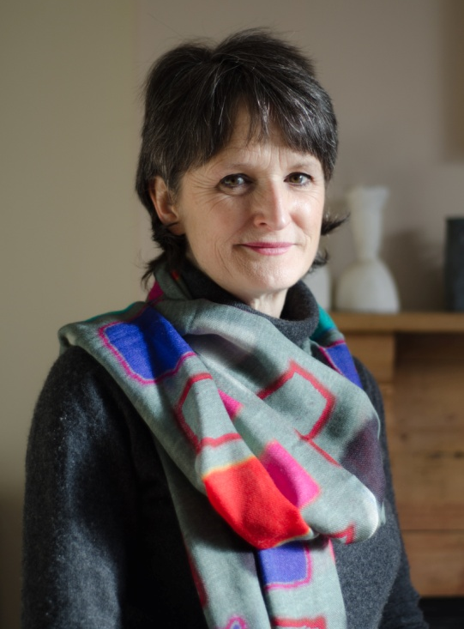
Jocelyn Dodd
Jocelyn Dodd is director of the Research Centre for Museums and Galleries (RCMG), School of Museum Studies, University of Leicester. RCMG research stimulates new thinking and practice enabling cultural organisations to become more ambitious and impactful in nurturing more equitable and inclusive societies. A major research strand is focused on difference, disability and museums, an area she has worked on with her colleague Richard Sandell for the last 15 years. Their most recent research is Exceptional & Extraordinary: Unruly bodies and minds in the medical museum.

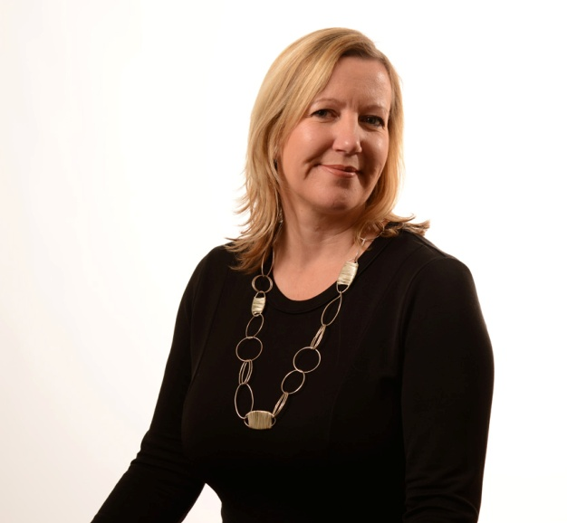
Sharon Heal
Sharon is the director of the Museums Association, a professional membership organisation that campaigns to promote the value of museums to society. She regularly comments on museums and cultural policy in the UK; speaks at conferences and events in the UK and internationally; and has published extensively. She is the chair of the Museum of Homelessness, a board member of Vocaleyes and a member of the Museum Slaskie Council, Poland. Sharon’s background is in journalism, event creation and policy development. She has lectured in journalism, the history of museums and museum ethics and has judged prizes and awards including the Clore Award for Museum Learning.

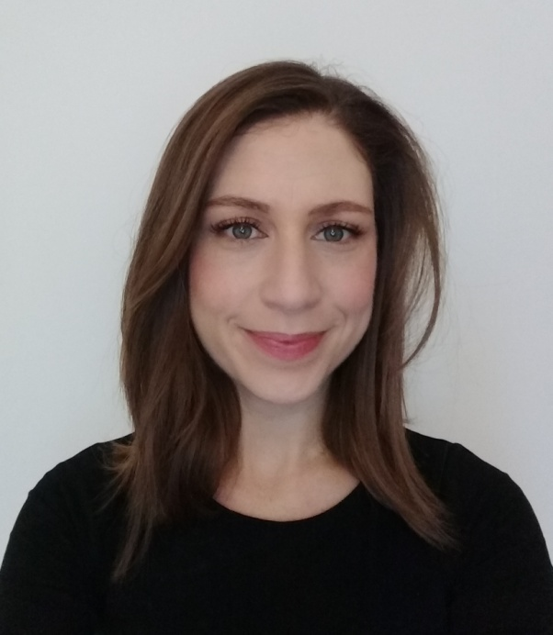
Anna Fineman
Anna Fineman is the Museums, Galleries and Heritage Programme Manager for VocalEyes, working with museums across the UK to improve accessibility for blind and partially sighted visitors. She has broad experience across the museum sector within exhibitions and interpretation. Prior to joining VocalEyes in 2016 she held posts at the V&A, White Lodge Museum at The Royal Ballet School, Arnolfini, and the University of Bristol Theatre Collection. She has a wide educational background that includes a BA in Social Psychology from the University of Sussex, a PGCE from Durham University, and an MA in Art Gallery & Museum Studies from the University of Manchester. Anna takes an audience-focused approach, and is dedicated to exploring creative ways to support broader access to museums, and increased enjoyment of their sites and collections.

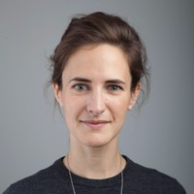
Charlotte Kingston
Charlotte is the curator of the three nationally-significant exhibitions by History of Place – 'Brave Poor Things: Reclaiming Bristol's Disability History' at M Shed in Bristol; 'The Blind School: Pioneering People and Places' at the Museum of Liverpool; and the display 'Without Walls: Disability and Innovation in Building Design' at the Victoria and Albert Museum, London.

Charlotte's recent projects include developing the interpretation, content and design for: ‘Seamus Heaney: Listen Now Again’, Dublin; The Museum of Literature Ireland (MOLI), Dublin; The Courtauld Institute of Art, London; Brooklands Museum, Surrey'; and 'Twilight People: Stories of Faith and Gender Beyond the Binary' with Liberal Judaism. Having spent the past six years at exhibition design company Ralph Appelbaum Associates, Charlotte will be taking up a new role as Head of Interpretation and Design at the National Railway Museum, York, in March.

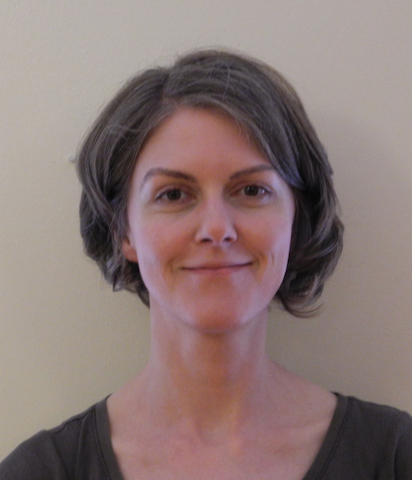
Karen MacDonald
Karen is an exhibitions officer at Bristol Culture, where she coordinates exhibitions at M Shed and Bristol Museum & Art Gallery. She has previously worked in art settings, including Salisbury Arts Centre where she managed the Visual Arts programme; Filmpro, which supports disabled artists working with digital media; and various participatory arts organisations working with diverse communities.

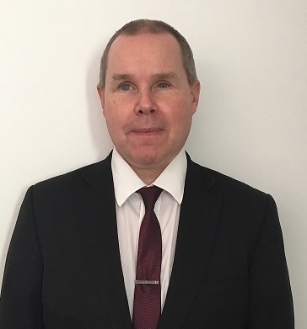

Barry Ginley
Barry is the Equality and Access Advisor at the Victoria & Albert Museum V&A in London, where he has worked since 2002. The role is varied, dealing with all aspects of the Museum’s work:
- Developing policies and strategy
- Design of buildings, galleries and accessible interpretation
- Delivering staff training
- Managing an accessible talks programme
This was a new area of work for Barry as his previous work experience was providing a leisure consultancy service to the Royal National Institute of the Blind, establishing Soccer Sight and Activate; and access consultancy to several property service companies. Barry is a member of the Built Environment Access Panel for the London Legacy Development Corporation; an advisor to the UK governments Paralympic Legacy Advisory Group; and sits on the board of the Global Disability Innovation Hub.
After an eye operation in 1994, which went wrong, Barry has been visually impaired. To help rebuild his life, he studied at the University of Reading, gaining an MSc in Inclusive Environments Design and Management in 2001; and in September 2017, Barry graduated with an Executive MBA from Henley Business School.

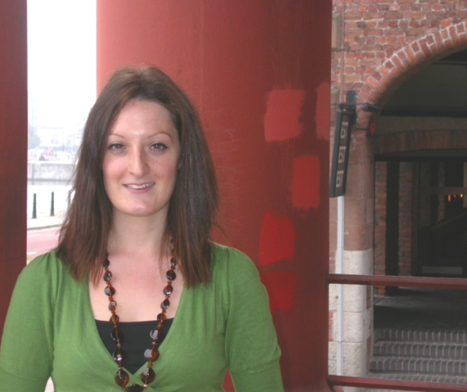
Kay Jones
Kay Jones is curator of urban community history at the Museum of Liverpool. She develops exhibitions and displays in collaboration with local community groups and organisations to tell hidden and diverse stories. She is responsible for the management and development of the local, national and internationally important social and community history collections. The wide-ranging collections reflect the changing history of the city and the diverse stories and experiences of Liverpool people. She has worked in a variety of city history museums and heritage organisations since 1999.
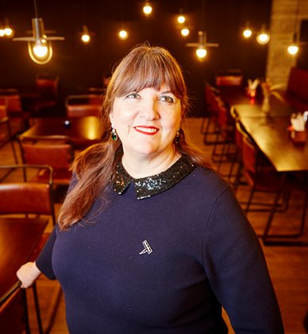

Ruth Gould MBE
Ruth Gould is the Artistic Director of DaDaFest, a disability-led charity based in Liverpool and home to the world’s leading Disability and Deaf arts festival. Her vision is to empower, develop and celebrate talent and excellence in disability and deaf arts. She is a passionate advocate of the social model and using art to transform culture and attitudes around disability. Ruth is also an advisory member for St Helens Cultural Hubs, the Granada Foundation, Liverpool City Council Tourism and Culture Select Committee, and the National Disability Arts Collection & Archive. She serves on the Board of DisArt (Michigan, US); is Vice Chair of Creative Case for the North and Chair of the Unlimited Commissioning Panel. Ruth was awarded a Winston Churchill Travel Fellowship in 2014 to help establish connections between disability organisations around the world, and in April 2015 she was appointed a Deputy Lieutenant for Merseyside. In 2016, Ruth was made an honorary Canon at Liverpool Cathedral, and awarded an MBE in the Queen’s 90th Birthday Honours list in recognition of her work. She is also an honorary fellow of Liverpool John Moore’s University.

