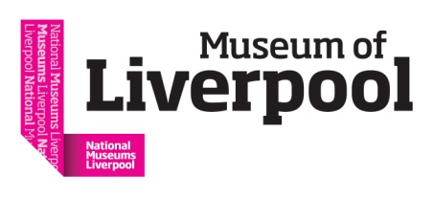
Rethinking Disability:
What needs to change in Museums and Galleries?
#RethinkDisability @H_O_P
Programme: Rethinking Disability Symposium
Friday 9th March 1pm–5.30pm
12.15pm-12.45pm Tour of The Blind School: Pioneering People and Places exhibition
1pm Welcome by Museum of Liverpool and housekeeping
1.05pm Opening remarks and framing the afternoon by Esther Fox, Accentuate
1.15pm Jocelyn Dodd, Director Research Centre for Museums and Galleries (RCMG), The University of Leicester
1.35pm Sharon Heal, Director of the Museums Association
1.50pm Questions
2.05pm Anna Fineman, Museums, Galleries and Heritage Programme Manager, Vocaleyes
2.25pm Questions
2.30pm Tea break and an opportunity to see The Blind School exhibition
3.00pm Chaired panel discussion with: Barry Ginley, Head of Disability and Social Inclusion, The Victoria and Albert Museum London., Kay Jones, Curator of Community History, Museum of Liverpool., Karen MacDonald, Engagement Officer (Exhibitions) Bristol Museums, Galleries and Archives., and Charlotte Kingston, History of Place Curator. Panel chaired by Esther Fox, Head of Accentuate.
4.00pm “Provocation” by Ruth Gould MBE
4.10pm Questions for panel and Ruth Gould
4.30pm-5.30pm Networking drinks reception

